

**WINTERFEST TWIRLING COMPETITION | JAN 31 – FEB 02, 2025**

[**HOLIDAY INN EXPRESS HOTEL & SUITES - OPELIKA**](https://www.aotourism.com/Accommodations/29/Holiday-Inn-Express-Hotel--Suites---Opelika/)

**RATE:** $124/night

**DEADLINE:** Book by **January 17, 2025** to receive rate

**DETAILS:** [**Click to Book**](https://www.hiexpress.com/redirect?path=rates&brandCode=EX&localeCode=en&regionCode=1&hotelCode=AUOOP&checkInDate=31&checkInMonthYear=002025&checkOutDate=02&checkOutMonthYear=012025&_PMID=99801505&GPC=WFT&cn=no&viewfullsite=true)

**PHONE:** (334) 749-5250

[**FAIRFIELD INN & SUITES AUBURN/OPELIKA**](https://www.aotourism.com/Accommodations/28/Fairfield-Inn--Suites-AuburnOpelika/)

**RATE:** $139/night

**DEADLINE:** Book by **January 17, 2025** to receive rate

**DETAILS:** [**Click to Book**](https://www.marriott.com/event-reservations/reservation-link.mi?id=1720647593552&key=GRP&app=resvlink)

**PHONE:** (334) 742-2590

[**HOME2 SUITES BY HILTON**](https://www.aotourism.com/Accommodations/49/Home2-Suites-by-Hilton/)

**RATE:** $109/night

**DEADLINE:** Book by **January 16, 2025** to receive rate

**DETAILS:** [**Click to Book**](https://group.home2suites.com/swg3uc)

**PHONE:** [(334) 737-5155](https://www.google.com/search?gs_ssp=eJzj4tZP1zcsq0iuMM0pMWC0UjWosLCwSLY0MrdINUhMtjCxNLQyqEgyNEtLNTaxSEyzTE5OTE72Es9NLCrKzC8pUUgvSsxLUchLLMnMz0vMAQCA4hit&q=marriott+grand+national&rlz=1C5CHFA_enUS890US891&oq=marriott+gran&aqs=chrome.1.69i57j46i39i175i199j46i175i199i433l2j46i175i199l2j0j69i60.2604j0j4&sourceid=chrome&ie=UTF-8)

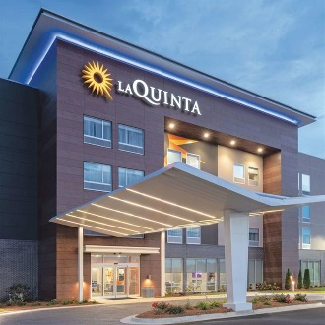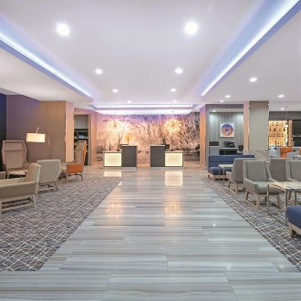

[**LA QUINTA INN & SUITES OPELIKA/AUBURN**](https://www.aotourism.com/Accommodations/51/La-Quinta-Inn--Suites-OpelikaAuburn/)

**RATE:** $149/night

**DEADLINE:** Book by **January 17, 2025** to receive rate

**DETAILS:** [**Click to Book**](https://www.wyndhamhotels.com/laquinta/opelika-alabama/la-quinta-opelika/rooms-rates?brand_id=LQ&checkInDate=1/31/2025&checkOutDate=2/2/2025&useWRPoints=false&children=0&groupCode=013125WIN&adults=1&rooms=1&loc=ChIJA-N6gCSTjIgRJUTlNzGjC1E&sessionId=1721762175)

**PHONE:** (334) 748-9000

[**AUBURN MARRIOTT OPELIKA RESORT & SPA AT GRAND NATIONAL**](https://www.aotourism.com/Accommodations/12/The-Marriott-at-Grand-National/)

**RATE:** $142/night *$30/night resort fee waived

**DEADLINE:** Book by **January 10, 2025** to receive rate

**DETAILS:** [**Click to Book**](https://www.marriott.com/event-reservations/reservation-link.mi?id=1730840699958&key=GRP&guestreslink2=true)

**PHONE:** [(334) 741-9292](https://www.google.com/search?gs_ssp=eJzj4tZP1zcsq0iuMM0pMWC0UjWosLCwSLY0MrdINUhMtjCxNLQyqEgyNEtLNTaxSEyzTE5OTE72Es9NLCrKzC8pUUgvSsxLUchLLMnMz0vMAQCA4hit&q=marriott+grand+national&rlz=1C5CHFA_enUS890US891&oq=marriott+gran&aqs=chrome.1.69i57j46i39i175i199j46i175i199i433l2j46i175i199l2j0j69i60.2604j0j4&sourceid=chrome&ie=UTF-8)

**SHOW YOUR BADGE**

**While you’re here, enjoy some of our favorite local restaurants, shops, and attractions - and here’s a little discount to sweeten your stay! Simply *Show Your Badge (the digital coupon)* to participating businesses and receive the discount.**

[**Click here for discounts!**](https://www.aotourism.com/show-your-badge/)

**OTHER AREA INFORMATION**

* [**Group/Team Friendly Dining Options**](https://www.aotourism.com/Dining/)
* [**Explore other events going on in the area!**](https://www.aotourism.com/Calendar/)
* [**Fun activities for the whole team!**](https://www.aotourism.com/Recreation/)
* [**Guides & Maps**](https://www.aotourism.com/Materials/)